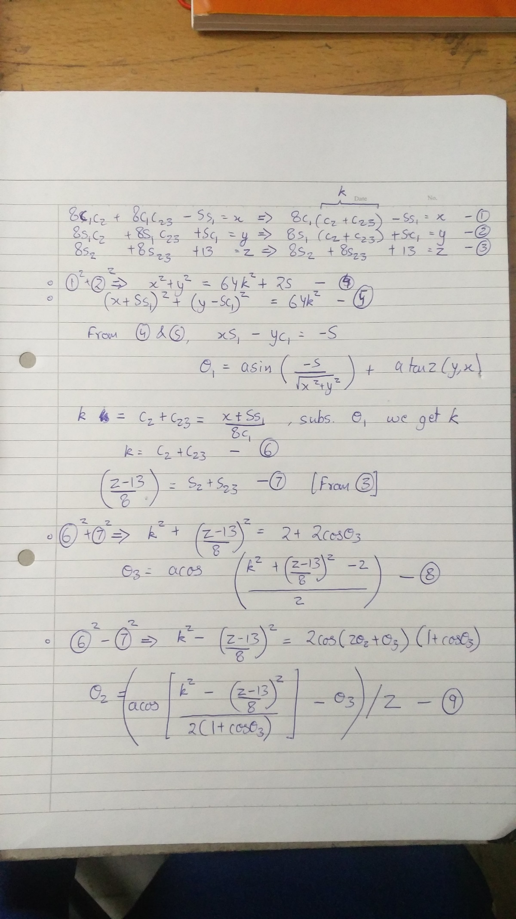

R36 =

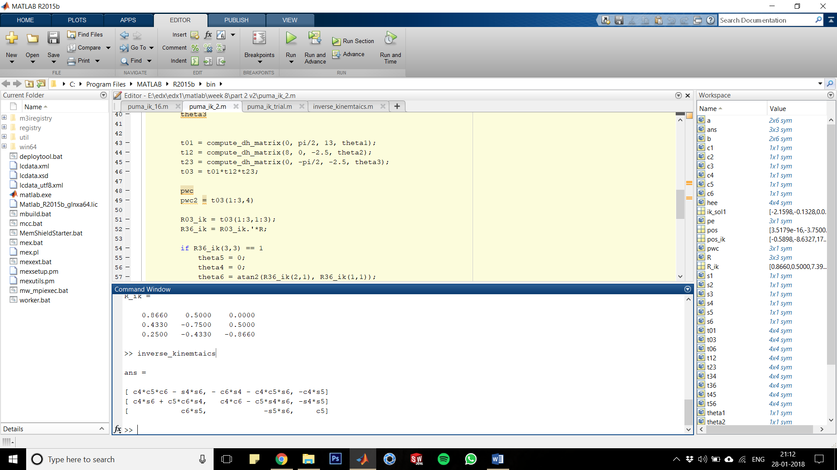

if R36(3,3) == 1

theta5 = 0;

theta4 = 0;

theta6 = atan2(R36(2,1), R36(1,1));

else

theta5 = acos(R36(3,3));

theta6 = atan2(-R36(3,2), R36(3,1));

theta4 = atan2(-R36(2,3),-R36(1,3));

end